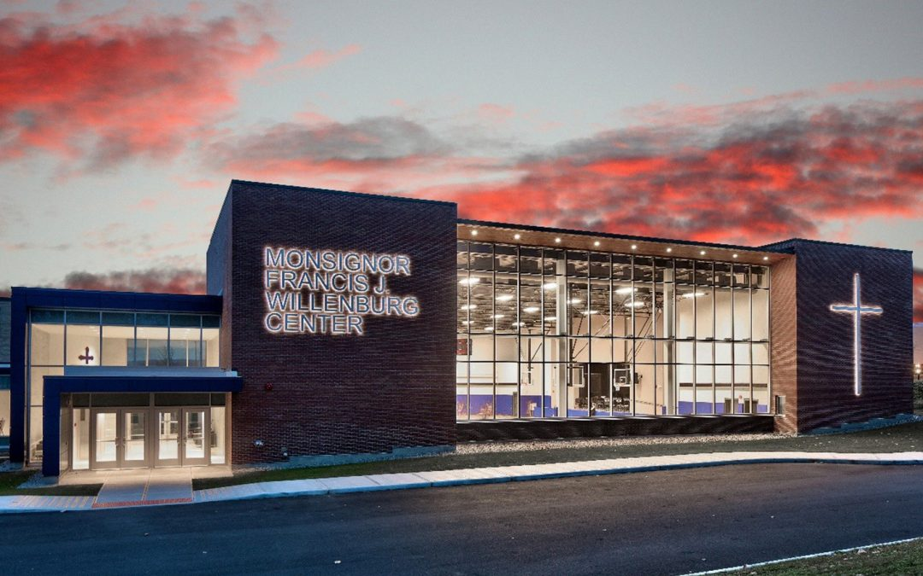

MINIMUM CAPACITY :-
The Minumum intake capacity
of students is between 300-620
children

LIBRARY :-
The Libarary is Available.

CANTEEN:-
The Canteen Facility is Available.

BOARDING :-
No availablility of boarding.

SPORTS :-
There are different categories
sports available.
Girls Volleyball
Boys Volleyball
Football

NOTRE DAME SCHOOL
YONKERS - SCHOOL

School Detail :-
At Notre Dame, we want to ensure that every student has the opportunity and the confidence to pursue their academic and extracurricular interests. We are thrilled to officially launch four new signature programs to students, including technology, engineering, and design ( T/ E / D ), video production, sports medicine, and leadership.
We encourage our students to develop a thirst for knowledge and truth, and we instill in them the determination to strive.

